**UI-Router**

* Routing means it is going to a particular location which we are giving in to the URL. And it will display the html contain which we are defined in template.
* It is mainly use for SPAs (single page applications) .so that in a page contain following things which are as follows:

Header

Left bar

Container

Footer

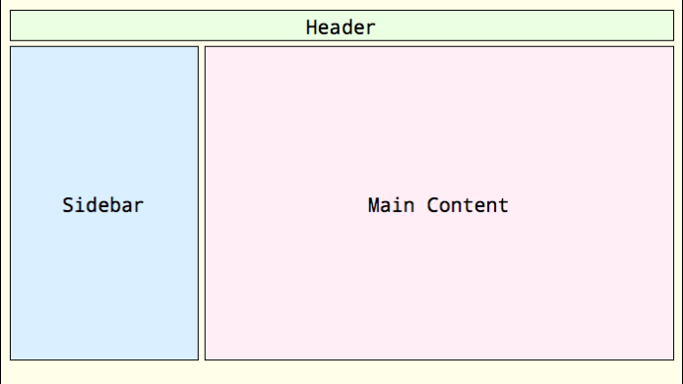

Only left bar and footer will be changed according to use flexibility.

* We are going for client side routing.
* For client side routing two most router is there namely.
  + ngRoute also name as Angular route
  + ui-route
  + etc
* ui-route is more flexible and it has more functionality rather than ngRoute.
* Ui-route build by separate Angular UI team.
* In ngRoute we are basically concentrate on routes but in ui-router we will focus on states.
* With the help of states we can provide more information surrounding the routing.
* Every states will be identified by its own name.
* In case of ui-router we have to configure $stateProvider instead of configure that $routeProvider.

**Advantage**

* With the help of ui-router we can show multiple view in a page.
  + It can be side by side.
  + Nested also.
* We can use nested states also.

**Steps to working with ui-router**

* Include ‘ui-router’ module.
  + Angular-ui-router.js after angular.js

(we can copy that link from google search angular-ui-router-cdnjs.com ) or inject this path of angular-ui-router.min.js URL

<script src=”https://cdnjs.cloudflare.com/ajax/libs/angular-ui-router/0.3.2/angular-ui-router.min.js”></script>

* Then create one js file in that js create Angular module like below:
  + var app = angular.module(‘appName’,[‘ui-router’]);
* configure the states like below:
  + app.config([‘$stateProvider’,function($stateProvider){

.state(‘firstTestState’,{

url : ‘/first-test’,

template : ‘<strong>your first ui-route project<strong>’

})

]);

* Declare ui-view attribute in html page to represent the template.

**How we are using in Project**

* First make on .js file for demo namely demoFirst.js in that file

var app = angular.module('myApp',['ui.router']);

app.config(['$stateProvider','$urlRouterProvider',function($stateProvider,$urlRouterProvider){

$stateProvider

.state('FirstTest',{

url : '/first-test',

template : '<strong>Hii its your first app test</strong>'

})

.state('Home',{

url : '/home-test',

template : '<strong>This is your first app ui-router Home</strong>'

})

.state('SecondTest',{

url : '/second-test',

template : '<strong>This is your containt Part</strong>'

})

.state('root',{

url : '/',

template : '<strong>no route find</strong>'

})

$urlRouterProvider.otherwise('/')

}]);

* Make one html page like below:

<html>

<head>

<title>FirstApp</title>

<script src="https://ajax.googleapis.com/ajax/libs/jquery/2.1.4/jquery.min.js" ></script>

<link rel="stylesheet" href="https://maxcdn.bootstrapcdn.com/bootstrap/3.3.7/css/bootstrap.min.css" />

<script src="https://maxcdn.bootstrapcdn.com/bootstrap/3.3.7/js/bootstrap.min.js" ></script>

<script src="https://ajax.googleapis.com/ajax/libs/angularjs/1.5.6/angular.min.js"></script>

<script src="https://cdnjs.cloudflare.com/ajax/libs/angular-ui-router/1.0.3/angular-ui-router.min.js"></script>

<script src="app.js"></script>

</head>

<body ng-app="myApp">

<div class="row">

<div class="col-sm-12" style="height:100px; background-color: grey">

<a href="#/home-test">Home</a> | UI-Router

</div>

</div>

<div class="row">

<div class="col-sm-3" style="height: 100%; background-color: darkgray">

<a href="#/first-test">First</a>

<br>

<a ui-sref="SecondTest()">Second</a>

</div>

<div class="col-sm-9" style="height: 100%; background-color: #fff">

<div ui-view></div>

</div>

</div>

</body>

</html>